QUESTION : 1
Create a SQL table called Restaurant with columns: id, name, cuisine, location, and average_rating. Insert at least 5 sample rows representing popular restaurants from Zomato:

TABLE Restaurant :
CREATE TABLE Restaurant(
id INT,
name VARCHAR(100),
cuisine VARCHAR(50),
location VARCHAR(100),
average_rating DECIMAL(2,1),
PRIMARY KEY(id)
);

INSERT INTO Restaurant(id,name,cuisine,location,average_rating)
VALUES
(1,'Barbeque Nation','North Indian','Ahmedabad',4.5),
(2,'Dominos','Pizza','Ahmedabad',4.2),
(3,'La Pinoz Pizza','Pizza','Surat',4.6),
(4,'Subway','Fast Food','Vadodara',4.1),
(5,'Honest','Gujarati','Rajkot',4.4) ;

SELECT * FROM Restaurant ;

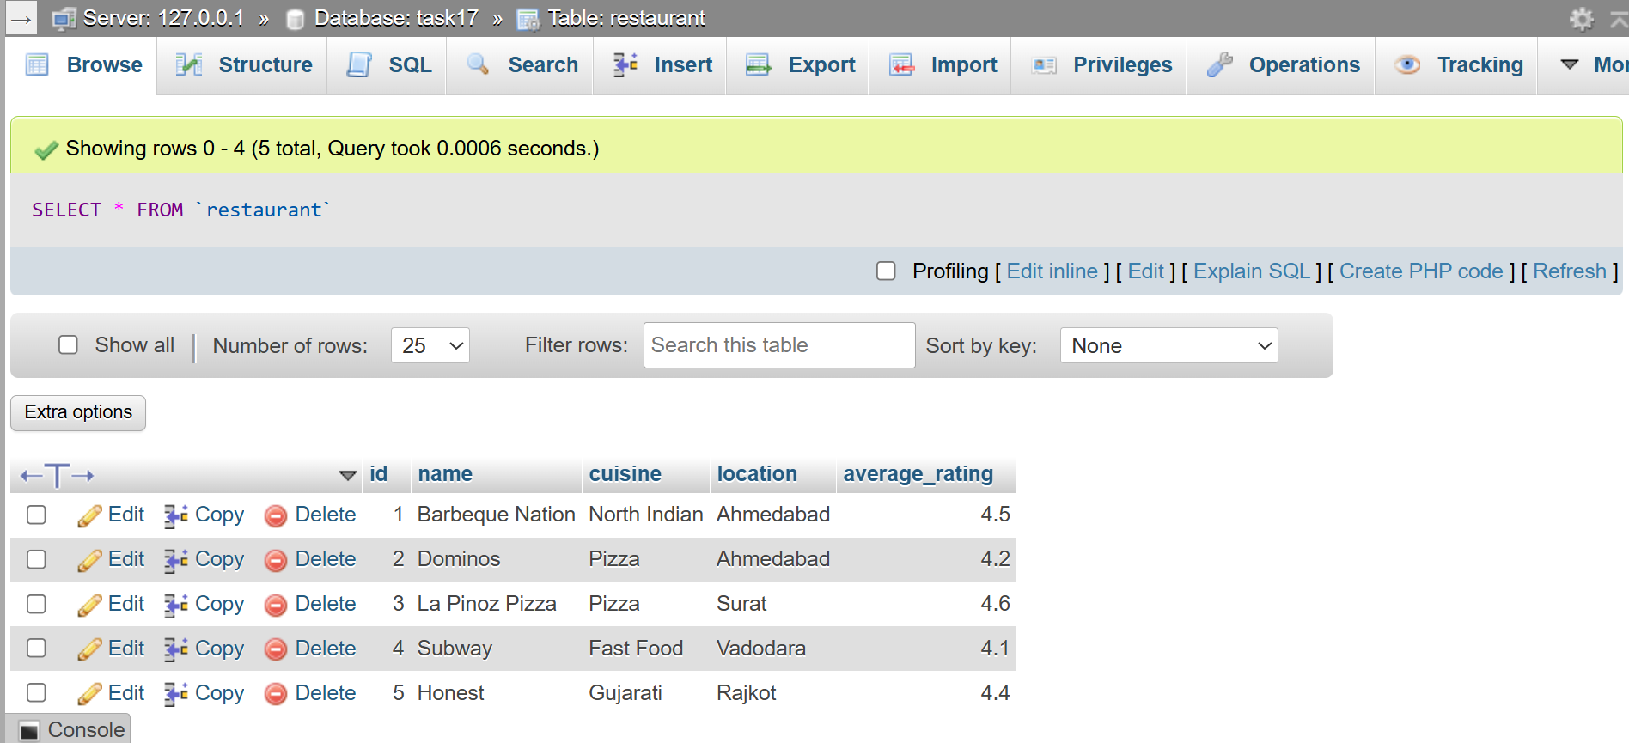
QUESTION : 2
Write a SQL query to generate a report showing the number of restaurants for each cuisine type from your Restaurant table, ordered by the count in descending order.<br><br><em><strong>Hint:</strong> Use GROUP BY and ORDER BY.</em> :

SELECT cuisine, COUNT(*) AS total_restaurants
FROM Restaurant
GROUP BY cuisine ORDER BY total_restaurants DESC;

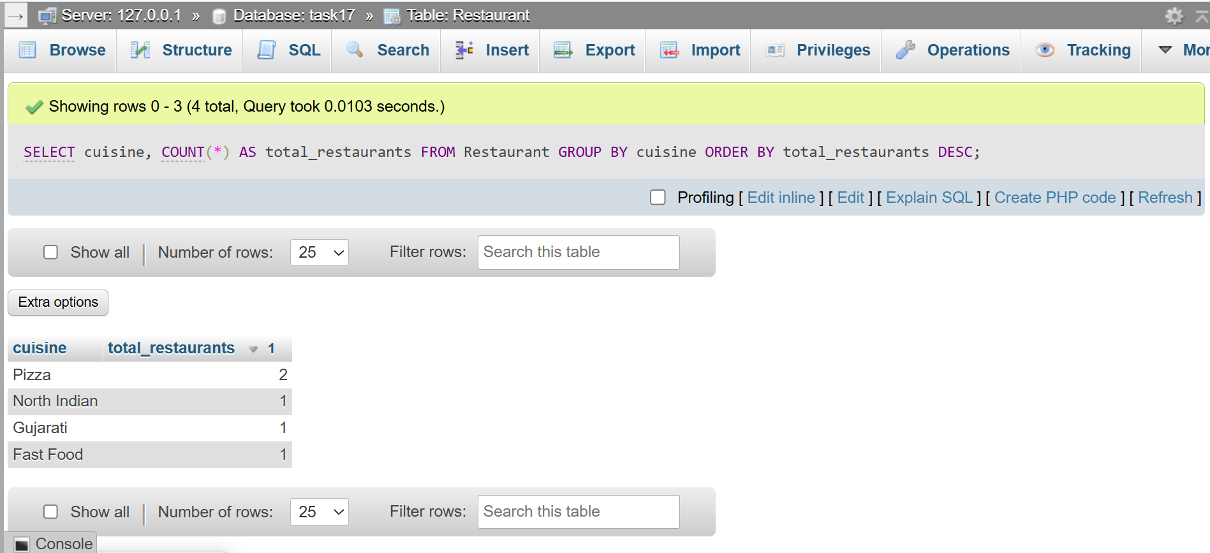
QUESTION : 3
Add a new table called Review with columns: id, restaurant_id, user_name, rating, and review_date. Insert at least 10 sample reviews, linking them to restaurants using restaurant_id :
TABLE Review :
CREATE TABLE Review(
id INT,
restaurant_id INT,
user_name VARCHAR(100),
rating DECIMAL(2,1),
review_date DATE,
PRIMARY KEY(id)
);
INSERT INTO Review(id,restaurant_id,user_name,rating,review_date)
VALUES
(1,1,'Vivek',5.0,'2026-07-01'),
(2,1,'Rahul',4.5,'2026-07-02'),
(3,2,'Priya',4.0,'2026-07-03'),
(4,2,'Amit',4.2,'2026-07-04'),
(5,3,'Neha',4.8,'2026-07-05'),
(6,3,'Riya',4.6,'2026-07-06'),
(7,4,'Karan',4.0,'2026-07-07'),
(8,4,'Sneha',4.1,'2026-07-08'),
(9,5,'Jay',4.5,'2026-07-09'),
(10,5,'Meera',4.3,'2026-07-10') ;
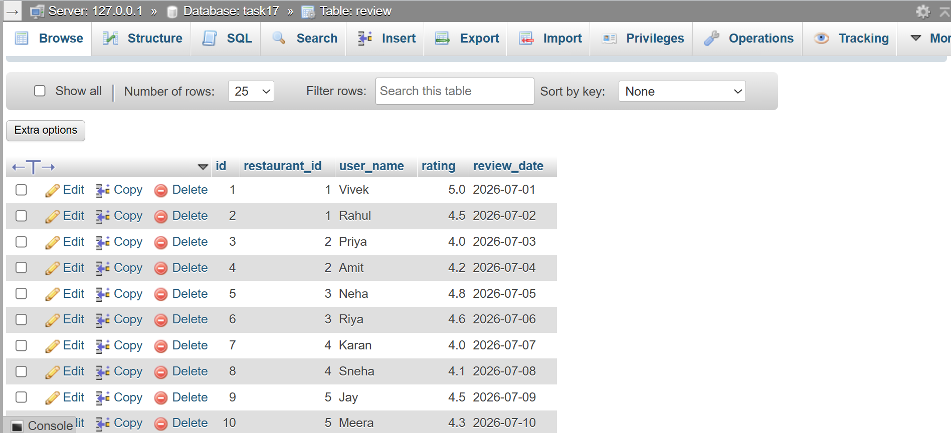
QUESTION : 4
Write a SQL query using a JOIN to display each restaurant's name, cuisine, and its average review rating (from the Review table), ordered by highest average rating first.<br><br><em><strong>Hint:</strong> Use JOIN and GROUP BY with aggregate functions.</em> :

SELECT restaurant.name,restaurant.cuisine,
AVG(review.rating) AS average_review_rating
FROM restaurant
JOIN review ON restaurant.id=review.restaurant_id
GROUP BY restaurant.id,restaurant.name,restaurant.cuisine
ORDER BY average_review_rating DESC ;
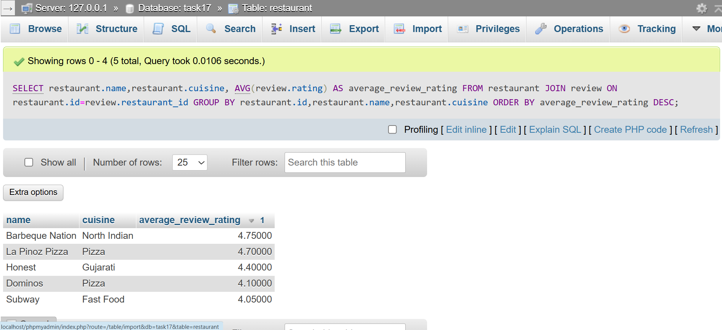

QUESTION : 5
Use a window function to rank restaurants by their average review rating within each cuisine type, showing the restaurant name, cuisine, average rating, and rank.<br><br><em><strong>Hint:</strong> Use the RANK() or DENSE_RANK() window function partitioned by cuisine.</em> :

SELECT restaurant.name,restaurant.cuisine,
AVG(review.rating) AS average_rating,
RANK() OVER(PARTITION BY restaurant.cuisine
ORDER BY AVG(review.rating) DESC) AS restaurant_rank
FROM restaurant JOIN review ON restaurant.id=review.restaurant_id
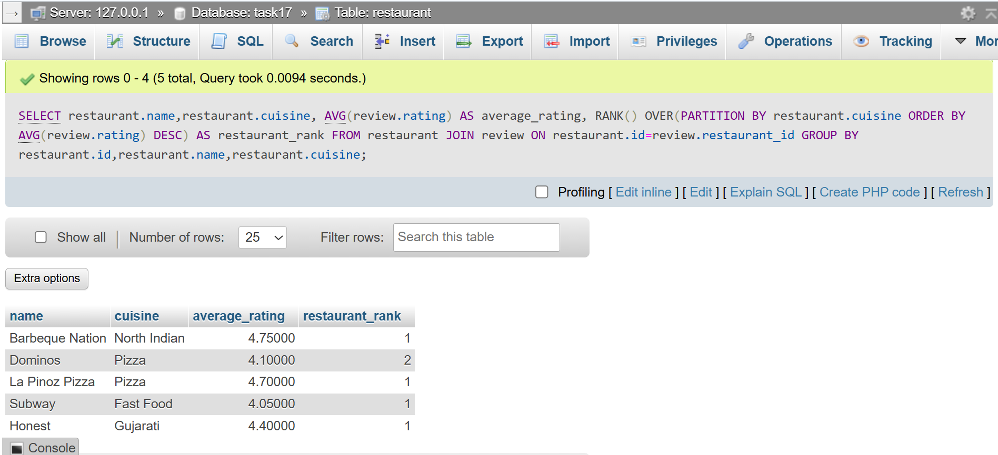
GROUP BY restaurant.id,restaurant.name,restaurant.cuisine ;

